**Pratice Making A** **Relay, Button, and LED**

*Damar Lintang Priyatama*

*Fakultas Vokasi, Universitas Brawijaya*

*Email:* [*damarpriya138@gmail.com*](mailto:damarpriya138@gmail.com)

**Abstract**

This project demonstrates the simulation of a relay system integrated with a button and an LED using an Arduino. The system operates by detecting the state of a pushbutton connected to a GPIO pin and triggering both an LED and a relay module based on the button's input. The button is configured with an internal pull-up resistor, so when it is pressed, the circuit is pulled low. The Arduino reads the button's state and accordingly controls the states of an LED and a relay. When the button is pressed, the LED turns on, and the relay is activated. Conversely, when the button is released, both the LED and the relay are turned off. This setup is ideal for simulating basic control mechanisms in embedded systems, demonstrating the use of GPIO pins, relay modules, and simple logic for interactive systems.

*Keywords—* *LED, Arduino, GPIO, Relay Module, Embedded Systems.*

**1. Introduction**

**1.1 Background**

In embedded systems, interaction between hardware components is a fundamental aspect of building practical applications. One such interaction is the combination of a pushbutton, an LED, and a relay, which can be used in various control systems. The button serves as a user input interface, while the LED provides feedback, and the relay acts as a switch to control external devices, such as motors, lights, or other high-power systems. The integration of these components is crucial in applications like home automation, security systems, and industrial automation.

A relay, in particular, is an electrically operated switch that allows a low-power signal (like an Arduino output) to control a high-power device. This is achieved by activating the relay coil with a low voltage, causing the internal switch to close or open the circuit, depending on the relay type. By incorporating a button, the system becomes interactive, allowing users to control the relay and LED based on the state of the button, turning on or off the connected devices.

**1.2 Purpose Experience**  
The primary purpose of this experiment is to demonstrate how a simple microcontroller, such as the Arduino, can be used to control and simulate the interaction between a pushbutton, an LED, and a relay. Ultimately, this experiment aims to enhance the user’s understanding of how different components in an embedded system work together and how to program them to perform interactive tasks. It also serves as an introduction to designing and debugging simple circuits and software for control systems.

**2. Methodology**

**2.1 Tools & Materials**

-Laptop Asus

-Vscode

-Arduino IDE

-ESP32 Board Support

**2.2 Implementation Steps**

-Open Arduino IDE and choose ESP32 for Proximity Sensor

-Arrange the ESP32 framework by Relay Module and pushbutton

-After that connect the cables according to GND and others

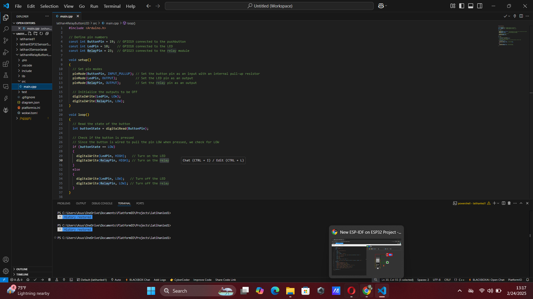-Type the code like this in main.c

-If the results of the relay module connect with push button to ESP32, then you have finished completing the Relay, Button, and LED module

**3. Results and Discussion**

**3.1 Experimental Results**

* diagram.json
* {
* "version": 1,
* "author": "Anonymous maker",
* "editor": "wokwi",
* "parts": [
* {
* "type": "board-esp32-devkit-c-v4",
* "id": "esp",
* "top": 48,
* "left": -110.36,
* "attrs": {
* "builder": "esp-idf"
* }
* },
* {
* "type": "wokwi-relay-module",
* "id": "relay1",
* "top": -28.6,
* "left": 86.4,
* "attrs": {}
* },
* {
* "type": "wokwi-pushbutton",
* "id": "btn1",
* "top": 121.4,
* "left": 86.4,
* "attrs": {
* "color": "green",
* "xray": "1"
* }
* },
* {
* "type": "wokwi-led",
* "id": "led1",
* "top": 178.8,
* "left": 32.6,
* "attrs": {
* "color": "red"
* }
* }
* ],
* "connections": [
* [
* "esp:TX",
* "$serialMonitor:RX",
* "",
* []
* ],
* [
* "esp:RX",
* "$serialMonitor:TX",
* "",
* []
* ],
* [
* "relay1:VCC",
* "esp:3V3",
* "red",
* [
* "h0"
* ]
* ],
* [
* "relay1:GND",
* "esp:GND.2",
* "black",
* [
* "h0"
* ]
* ],
* [
* "relay1:IN",
* "esp:23",
* "green",
* [
* "v-0.2",
* "h-86.4",
* "v105.6"
* ]
* ],
* [
* "btn1:1.l",
* "esp:19",
* "green",
* [
* "h0"
* ]
* ],
* [
* "btn1:2.l",
* "esp:GND.2",
* "green",
* [
* "h-19.2",
* "v-86.2"
* ]
* ],
* [
* "led1:C",
* "esp:GND.2",
* "green",
* [
* "h-9.2",
* "v-124.8"
* ]
* ],
* [
* "led1:A",
* "esp:18",
* "green",
* [
* "h9.6",
* "v-48"
* ]
* ]
* ],
* "dependencies": {}
* }
* 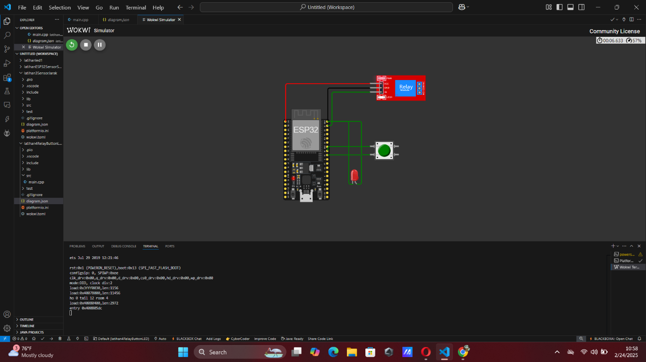Result Relay, Button, and LED

